Name ________________________________ AP Calculus
Section 4.3 Practice

Show all your work! Graphing Calculator allowed only on question 7.

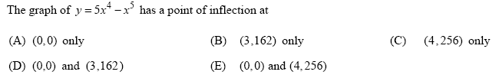
1.

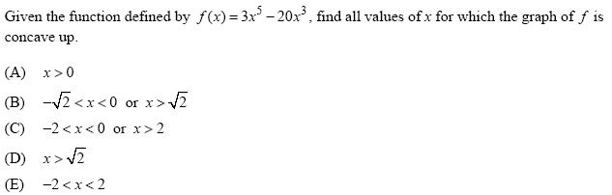
2.

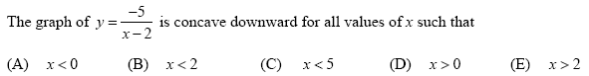
3.

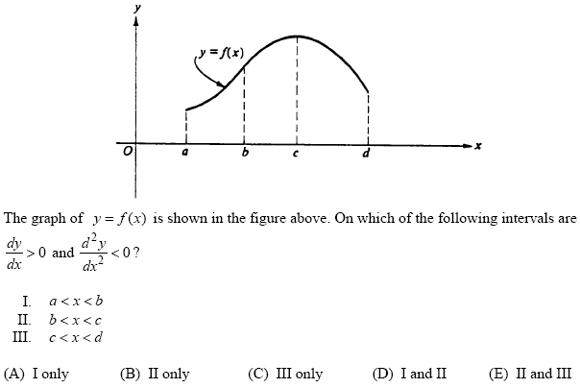
4.

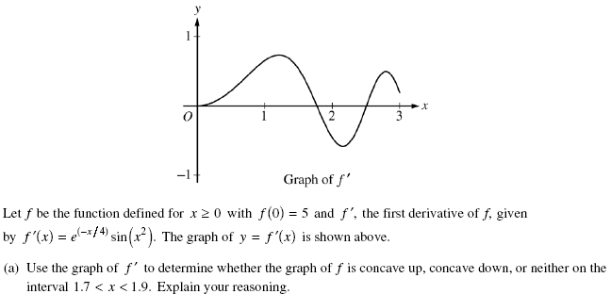
5.

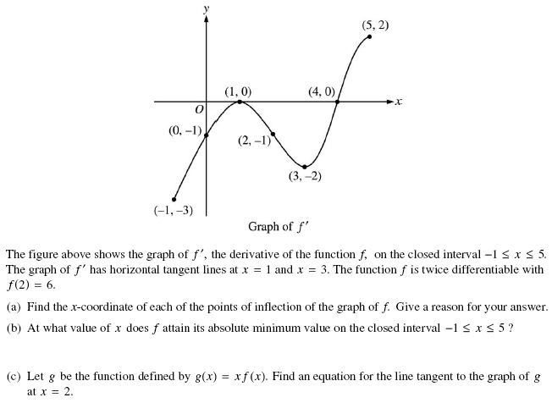
6.

*7.
